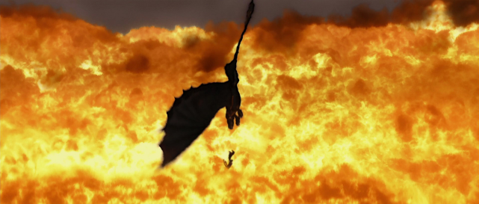My work is inspired by how to train your dragon’s climactic ending scene, however I couldn't create a dragon in maya, so I decided to stay with the fantasy route and used an alternative, a broom.

**Figure 1.** How to train your dragon – Hiccup falling

**Modelling**

My broom design is based of the centre broom in Figure 2, the challenge for this model was texturing the end of the broom.



**Figure 3.** Finished broom model

**Figure 2.** Little Witch Academia poster

For my model I removed the chain, as it would affect my rigging too much and add more work during the final animation to make sure it constantly moves. I attempted to go for the spiky feather design for the end of my broom but after a few attempts of texturing I decided to stick to a hay aesthetic for my texture.

The rigging process for my model was a success as it’s quite a simple model, the rigging only needed a few joints, however the problem came with weight painting and getting the model to move how I desired. Originally, I wanted the model to be quite bendy to exaggerate its movement but due to my inability to achieve this, the model fly’s as it looks, with the only successful part of my rigging/weight painting being the top of the model, which bends in the correct way.

**Animating**

The animation process was quite tedious with the most difficult thing being getting the Mise-en-Scène right. With bad lighting it didn’t matter how good my animation was, even in the final product you can see quite a few grainy parts where I have failed to achieve good lighting.

My animation takes place in the sky; therefore, I included a sun, a few clouds as well as some mountains to show just high an altitude my model was falling from, this help set the location as well as set the mood of the scene. I believe my main takeaway of my animation process would be to give myself more time to make better animations as well as sort out the lighting to get it perfect. xd

**Figure 4.** Connor McGregor money walk

My walk sequence was inspired by the Connor McGregor money walk, the most difficult part I found was making a clean loop, this can be seen in the jittery movements in the feet and elbow.

**Post-Production**

When I started creating the video for my walk, I used a crowd cheer for atmosphere as well as some faint footsteps as if they were picked up by a microphone, the footsteps I chose have a depth of field and so the furthest footstep from the screen is heard on a quieter level.

As I had storyboarded my work the post-production of my work was straightforward with colour correction and adding the stylistic choice I wanted to use.

**Figure 5.** Storyboard

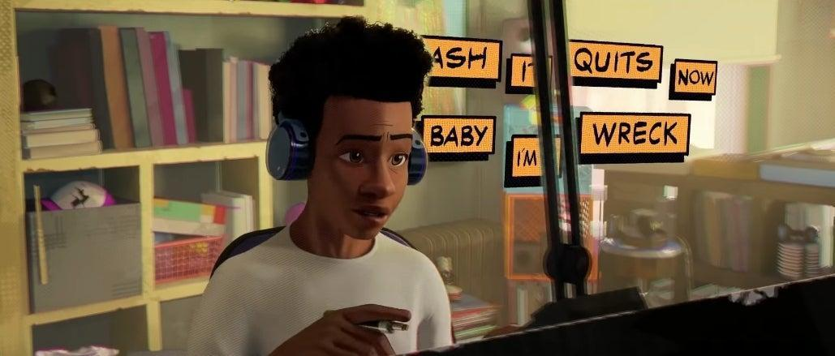For my video I wanted a comic book effect, heavily inspired by Spiderman into the Spider-Verse (Figure 5).

**Figure 6.** Miles singing

For sound effects, I included wind sounds for ambience as well as whoosh and page turning sounds to reinforce the idea of its comic book style. What would push my work to the next level is to have included better camera work when recording in Maya.

**Bibliography**

Betamax Crowd Cheering 004 (2020) *Sonic Bat.* [website] SoundSnap

Bottari, Jeff Guardian (2016) *Conor McGregor celebrates his KO victory*. Available from: https://www.theguardian.com/sport/live/2016/nov/12/ufc-205-conor-mcgregor-eddie-alvarez-live?filterKeyEvents=false [Accessed 04 May 2022]

comicbook (2018) *What Song Does Miles Sing in 'Spider-Man: Into The Spider-Verse?'*. Available from: https://comicbook.com/marvel/news/spider-verse-what-song-is-miles-singing/ [Accessed 04 May 2022]

Dreambox, Digital / YouTube (2021) *Model Low Poly Clouds In Maya | Simple Clouds*. Available from: https://www.youtube.com/watch?v=YOZo0VtLD5o [Accessed 27 April 2022]

Dreambox, Digital / YouTube (2021) *Model A Low Poly Floating Island in Maya | Rocky Platform*. Available from: https://www.youtube.com/watch?v=K7HruLyS-jE [Accessed 27 April 2022]

EFX SD I thought we had a connection 01 () *CA Sound*. [website] SoundSnap

Fandom (2021) *Official television series poster*. Available from: https://little-witch-academia.fandom.com/wiki/Little_Witch_Academia_(anime) [Accessed 04 May 2022]

Footsteps Carpet Walking Trainers 01 03 (2021) *InspectorJ*. [website] SoundSnap

Heart Beat Speed Up To Death 09 (2020) *CA Sound*. [website] SoundSnap

James Thatcher (2021) *Ash Meadows At Dawn 02*. SoundSnap [downlaod] [Accessed 03 May 2022]

Nature Africa Savanna Sunset Countryside Quite Ambience (2021) *SSL SOUNDSNAP*. [website] SoundSnap

ODEZA (2014) *Say My Name (feat. Zyra)* [CD] AUS/NZ:Bronson

Page Holster 04 (2021) *David Frederick*. [website] SoundSnap

Plastic - swishing, whipping, and whooshing 1 (2020) *Lukas Tvrdon*. [website] SoundSnap

Pop TS 12 () *Mechanical Wave*. [website] SoundSnap

screamers 02 () *Richard Humphries*. [website] SoundSnap

tumblr (2017) *Would movie toothless die for hiccup?*. Available from: https://kingofthewilderwest.tumblr.com/post/150232640674/would-movie-toothless-die-for-hiccup [Accessed 04 May 2022]

warfare battle axe swing 002 118886 (2018) *Alan McKinney*. [website] SoundSnap

Whoosh Swoosh Swing Fishing Pole DistHalf Fienup 025 () *David Fienup*. [website] SoundSnap